**Ex1 :Computer Networking Lab**

***Name: R. Athithraja***

***Reg.no: 2022503702***

***Ifconfig:***

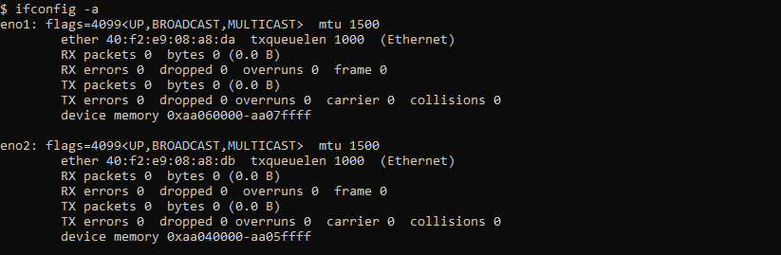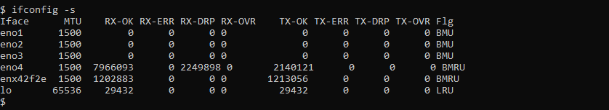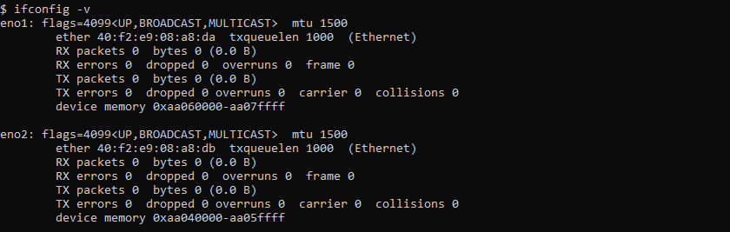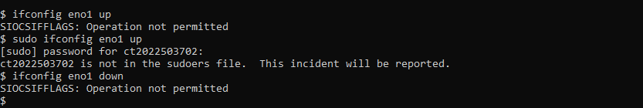

**Nslookup:**

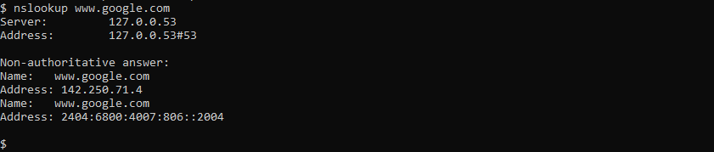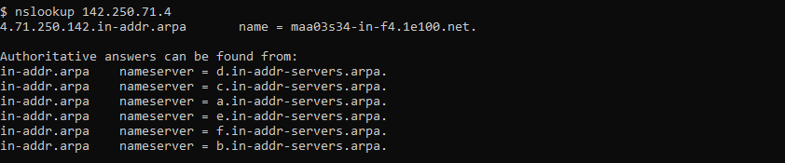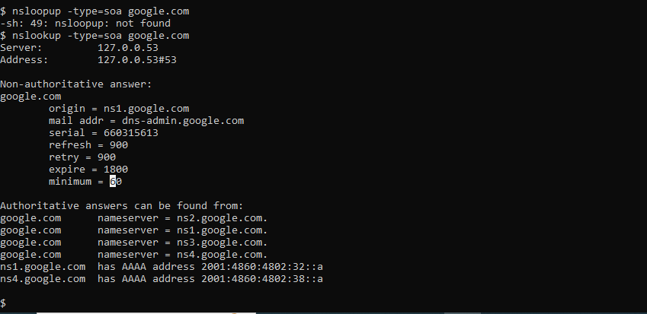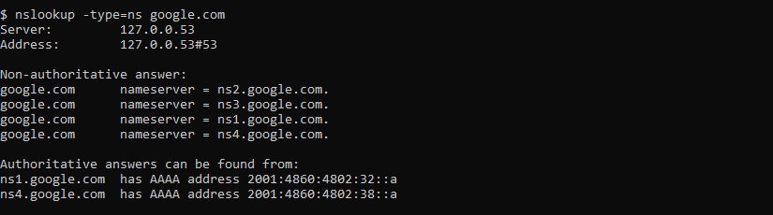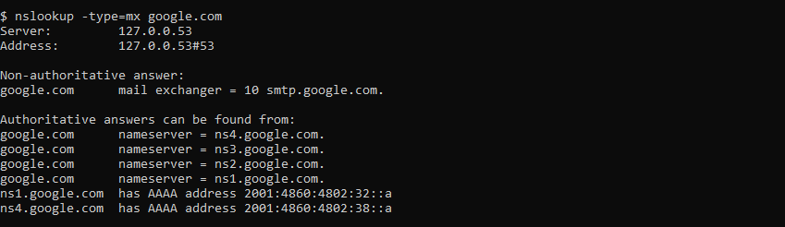

**Traceroute:**

**Ping:**

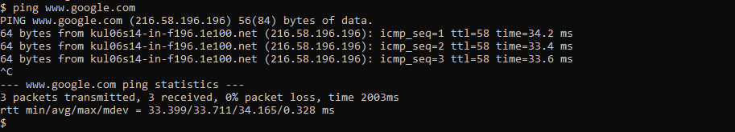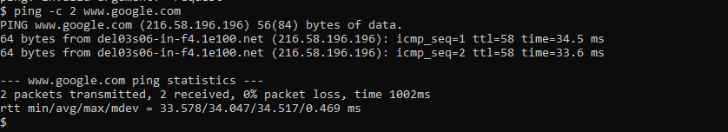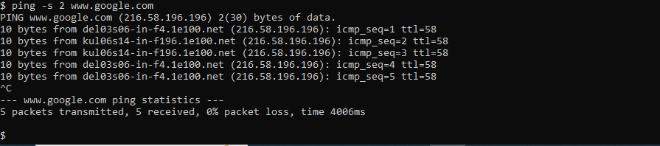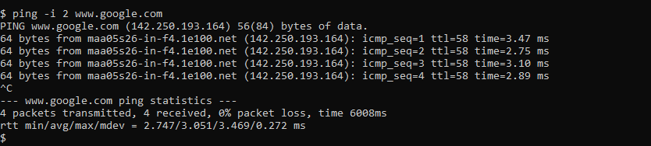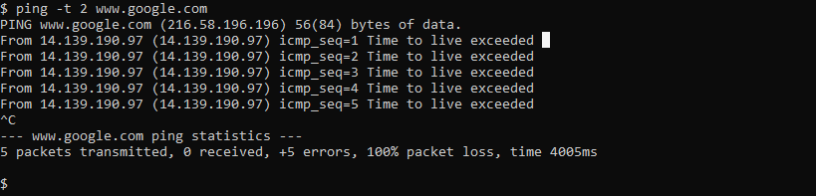

**Host:**

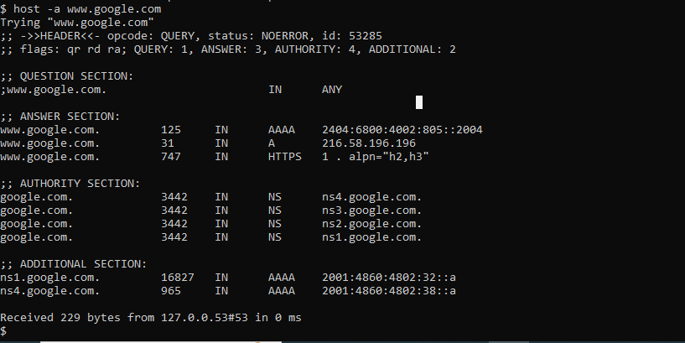**4.PNG**

**Route:**



**Dig:**

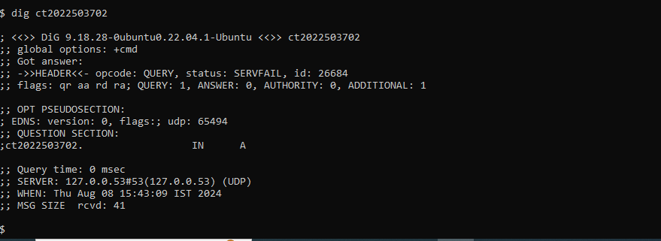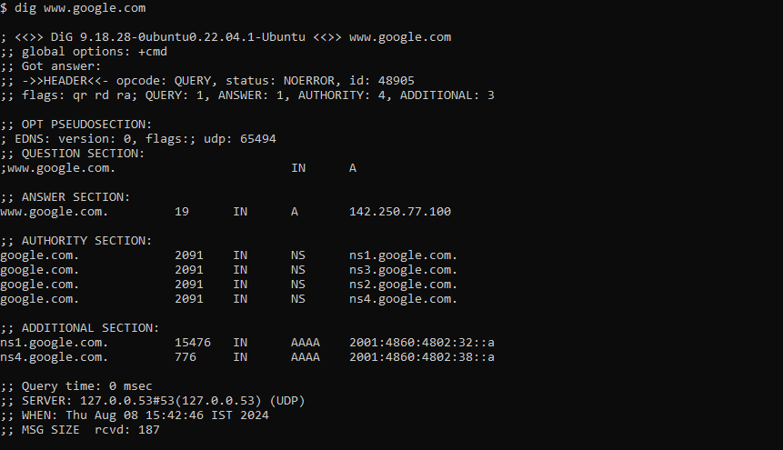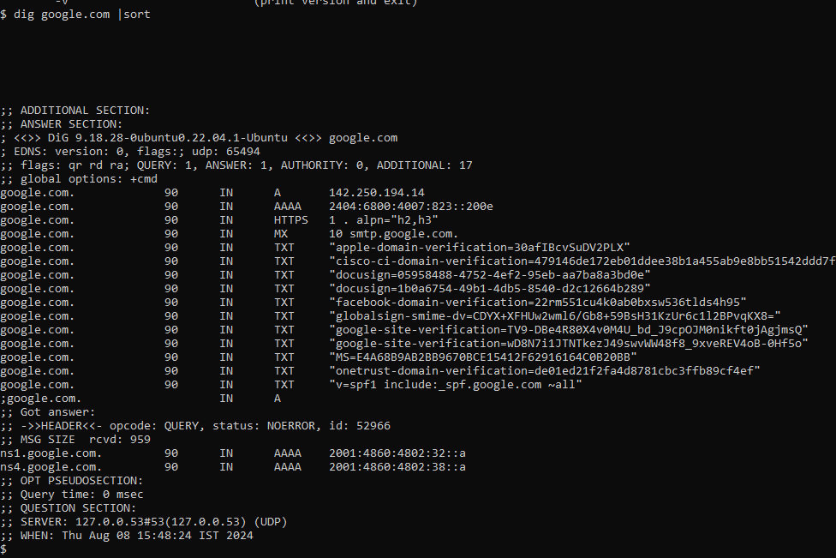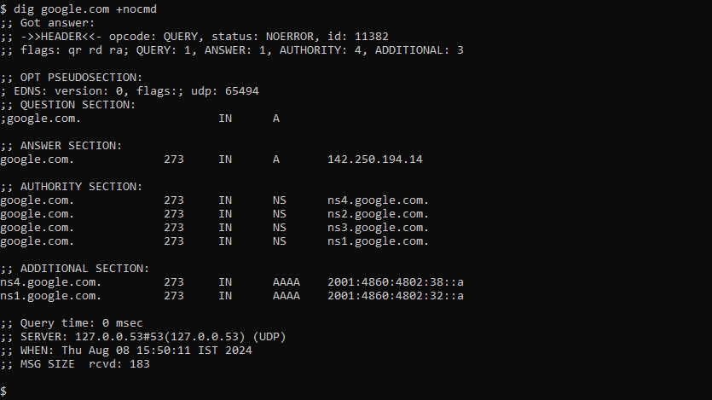**5.PNG6.PNG**